

**Tribhuvan University**

**Faculty of Humanities and Social Science**

**Project Proposal on:**

**Billing and Inventory Management System**

**Submitted to:**

**Department of Computer Application**

**Sungava College**

**Khairahani Chitwan**

**Date:**

***In the partial fulfilment of the requirement for the bachelor’s in computer application***

**Submitted by:**

Name: **Ghana Shyam Shrestha**

Semester: **6th**

Tu Registration No.: **6-2-1095-8-2021**

**Table of Contents**

List of Figures iii

List of Table iv

List of Abbreviations v

Chapter: 1 Introduction 1

1.1 Introduction 1

1.2 Problem Statement 1

1.3 Objectives 2

1.4 Scope 2

Chapter: 2 Background Study and Literature Review 3

2.1 Background Study 3

2.2 Literature Review 3

Chapter: 3 Methodology 5

3.1 System Analysis 5

3.1.1 Requirement Identification 5

3.1.2 Feasibility Study 6

3.1.3. Implementation Tools 7

3.2 System Design 8

3.2.1 Usecase Diagram 8

3.2.1 Object Modeling - Class Diagram 9

3.3 Project Schedule (Gantt Chart) 10

Chapter: 4 Conclusion 11

4.1 Expected Outcome 11

References 12

# List of Figures

Figure 2.1: Subscription price of Zoho Billing 4

Figure 3.1: Waterfall Model 5

Figure 3.2: Usecase Diagram 8

Figure 3.3: Class Diagram 9

# List of Table

Table 3.1:Gantt Chart 10

List of Abbreviations**:**

HTML: HyperText Markup Language

PHP: HyperText Preprocessor

XAMPP: X (cross platform), Apache, MySQL, PHP, Perl

SQL: Structured Query Language

CSS: Cascading Style Sheet

UI: User Interface

SDLC: System Development Life Cycle

# Chapter: 1 Introduction

## Introduction

Today’s technology plays a crucial role in every sector, yet many retail and wholesale businesses still rely on traditional methods for record-keeping and invoicing. This makes it difficult to track sales, calculate profits or losses, and manage inventory efficiently. As a result, businesses often spend hours on manual calculations, which consume valuable time and energy.

Our project aims to develop a billing and inventory management system that streamlines these processes. Our system will help users efficiently track sales, monitor inventory, and generate invoices, ultimately improving business operations and decision-making. Our system is designed with a user-friendly interface, ensuring smooth navigation and ease of use. Even users with minimal computer knowledge can operate it without any difficulties. With its intuitive design and straightforward functionality, businesses can efficiently manage their sales and inventory without facing operational challenges.

By embracing digital transformation, businesses can not only simplify their daily operations but also gain a competitive edge in the market. Our goal is to provide an efficient and reliable solution that helps businesses grow and adapt to the ever-evolving commercial landscape.

## Problem Statement

The problems that the current Billing and Inventory Management Systems have that our system can tackle:

* **Complex User Interface:** Existing systems often have a complex user interface, making it difficult for users to navigate and utilize all functions and features effectively. As a result, many users struggle to take full advantage of the system’s capabilities, leading to inefficiencies and frustration.
* **High Subscription Fees:** Many existing systems come with expensive monthly and yearly subscription fees, making them unaffordable for small and medium-sized businesses.
* **Requires Extensive Training:** Many systems require complex user interfaces, requiring staff to undergo long training before they can use the system efficiently. This causes a waste of valuable time.

## Objectives

The core objectives of initiating this project are listed below:

* To design a simple, elegant, and user-friendly user interface.
* To provide our customers with an affordable billing and inventory management system.
* To develop a system that users can operate with minimal instruction.

## Scope

The scope of the proposed Billing and Inventory Management System project is primarily aimed at small and medium-sized retail and wholesale businesses seeking an efficient and affordable solution for managing their billing and inventory.

The system will feature a user-friendly interface designed for ease of navigation, enabling users with minimal technical expertise to operate it without difficulties. With capabilities such as invoice generation, automatic inventory updates, and detailed sales reporting, users can efficiently monitor inventory levels and sales performance. This eliminates the need for manual calculations, allowing businesses to effortlessly ascertain profit margins and track stock availability in real-time.

Key features such as inventory updates, sales reporting, and invoice generation empower businesses to make informed decisions quickly. Ultimately, the billing and inventory management system seeks to improve overall operational efficiency and provide a competitive advantage in the market.

# Chapter: 2 Background Study and Literature Review

## Background Study

In today’s fast-paced business world, managing billing and inventory efficiently is crucial, especially for retail and wholesale businesses. However, many companies still rely on manual processes or outdated software, which often leads to errors, wasted time, and unnecessary hassles. A well-designed billing and inventory management system can simplify sales tracking, improve inventory control, and streamline invoicing—ultimately making operations smoother and more efficient.

Traditionally, businesses handled invoices through manual data entry, spreadsheets, and physical stock tracking. While these methods worked in the past, they are slow, error-prone, and difficult to scale. With advancements in technology, automated billing and inventory systems have become a game-changer, helping businesses reduce mistakes, save time, and stay competitive in an increasingly digital marketplace.

## Literature Review

Existing research on billing and inventory management systems highlights the importance of efficient transaction management and cost-effective solutions, with a focus on streamlining processes through digitalization, though many systems still rely on traditional methods without advanced features like QR codes or mobile integration. [1]

Our billing and inventory management system will aim to provide an affordable, user-friendly system that allows businesses to effortlessly ascertain profit margins and track stock availability in real-time. Which will provide help to make effective decisions quickly. I visited many billing and inventory management system websites and saw that their subscription fee is very expensive making it impossible to afford many small and medium-sized retail and wholesale businesses. The following image is from one of the websites I visited showing its subscription price. [2]

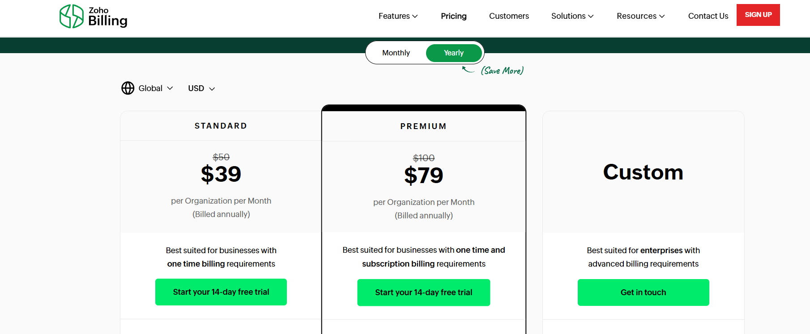

**Figure 2.1: Subscription price of Zoho Billing**

The problem of expensive subscriptions will be solved by our project.

# Chapter: 3 Methodology

Since our requirements are clear and we know what we want, we decided to use the **Waterfall Model** for further development of our website. It is used for short projects and is easy to use.

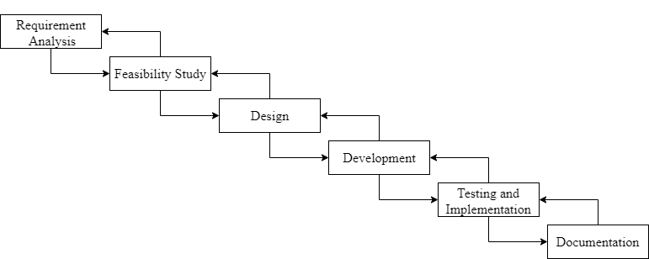

**Figure 3.1: Waterfall Model**

In the Waterfall Model, a sequential approach that involves a linear progression through different phases of software development, including planning, requirements gathering, design, implementation, testing, and maintenance is used. The waterfall model will help us ensure that each stage of the project is completed before moving on to the next one. This will help us stay focused and ensure that we meet our project goals within the given timeframe.

## System Analysis

### Requirement Identification

For our system, requirement is identified through functional and non-functional requirements.

1. **Functional Requirement**

* **For Shop Owner**
* User registration and login
* Create a Staff Account
* Manage Staff and Inventory
* Manage Supplier list
* Manage and view sales report
* Manage and view inventory report
* Add item in inventory
* Create invoice
* Can report problem or error occur to admin
* **For Staff**
* Staff Login
* Create Invoice
* Manage Inventory
* View Sales Report
* View Inventory Report
* Add item in inventory
* Can report problem or error occur to admin
* **For Admin**
* Admin Login
* Manage User
* View error report from user

1. **Non-Functional Requirement**

* Usability
* Performance
* Security
* Maintainability

### Feasibility Study

1. **Time Feasibility:**

The project’s timeline has been carefully planned according to the availability of resources. Each phase, including planning, design, development, testing and implementation has been allocated appropriate timeframes to ensure a well-structured and efficient progression of the project.

1. **Technical Feasibility:**

The required technology and resources essential for the development of the project are readily available, presenting no concerns in this aspect. Moreover, the development team possesses the required skill set and expertise for the successful implementation of the proposed project.

1. **Operational Feasibility:**

The system is designed to be user-friendly and easy to use. It is not required that the operator of the system have strong technical knowledge. As such, any person with basic computer skills will be able to use the system for their required objectives.

1. **Economic Feasibility:**

As the scope of the project is modest, the estimated costs for the development, maintenance, infrastructure and operation are well within the allocated budget. The expected benefits of the system are well justified compared to the costs of the system.

### 3.1.3. Implementation Tools

1. **Hardware Requirements:**

* More than 4 core Processor
* More than 2 GB Primary Memory
* More than 10 GB Hard Drive
* Basic Input / Output Devices

1. **Software Requirements:**

* Windows 10/11
* Local Development Web Server (XAMPP, WAMP etc.)
* Code Editor (Visual Studio Code)
* Web Browser

1. **Front-end:**

* HTML (Hypertext Markup Language)
* CSS (Cascading Style Sheet)
* JS (JavaScript)

1. **Back-end:**

* MySQL
* PHP (Hypertext Preprocessor)

## System Design

### Usecase Diagram

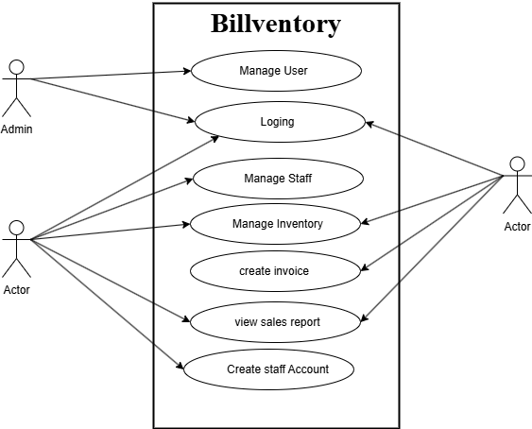

**Figure 2.2: Usecase Diagram**

### Object Modeling - Class Diagram

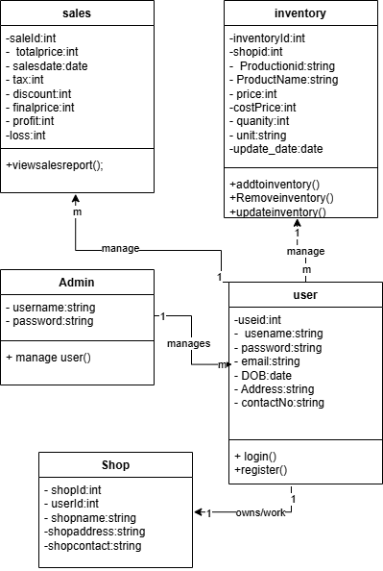

**Figure 3.3: Class Diagram**

## Project Schedule (Gantt Chart)

**Table 3.1:Gantt Chart**

|  |  |  |  |  |  |  |  |  |  |  |  |  |
| --- | --- | --- | --- | --- | --- | --- | --- | --- | --- | --- | --- | --- |
| **Activity Week** | 1 | 2 | 3 | 4 | 5 | 6 | 7 | 8 | 9 | 10 | 11 | 12 |
| Requirement Analysis |  |  |  |  |  |  |  |  |  |  |  |  |
| Feasibility Study |  |  |  |  |  |  |  |  |  |  |  |  |
| Design |  |  |  |  |  |  |  |  |  |  |  |  |
| Development |  |  |  |  |  |  |  |  |  |  |  |  |
| Testing and Implementation |  |  |  |  |  |  |  |  |  |  |  |  |
| Documentation |  |  |  |  |  |  |  |  |  |  |  |  |

## Algorithm

In this project, the following algorithm will be used.

1. Password Hashed
2. OTP generation
3. Tiered Discount Algorithm

# Chapter: 4 Conclusion

In conclusion, the development of an efficient billing inventory management system represents a significant step forward in addressing the challenges faced by small and medium-sized businesses in managing their financial transactions and inventory. By simplifying the user interface, reducing costs, and minimizing the need for extensive training, our system aims to empower users to operate effectively and confidently.

## Expected Outcome

The project is set to revolutionize the way billing and inventory management systems function by introducing an accessible and user-friendly solution that combines speed and reliability. Our aim is not just to meet the existing challenges, but to surpass them—creating a system that transforms the billing and inventory management experience entirely.

# References

|  |  |
| --- | --- |
| [1] | Baswaraju Swathi, Abhishek Kumar, Ishu Kumar, Vathsavi Venkat, "Implementation of Improved Billing System," *International Journal of Scientific Research in Computer Science, Engineering and Information Technology (IJSRCSEIT),* vol. 6, no. 3, p. 5, May-June-2020. |
| [2] | Zoho.com. [Online]. Available: https://www.zoho.com/. |